**Exp. 10 Clone**

**Aim:**

To create a Snapshot of a VM and Test it by loading the Previous Version/Cloned VM using a virtual box.

**Procedure:**

* Open virtual box application
* Then click on new button to create a new VM
* Enter the name and select the required ISO file
* Enter credentials like username and password
* In Machine from toolbar, select snapshot.
* Now the snapshot is taken, which can be used to load the VM from the snapshot

**Output:**

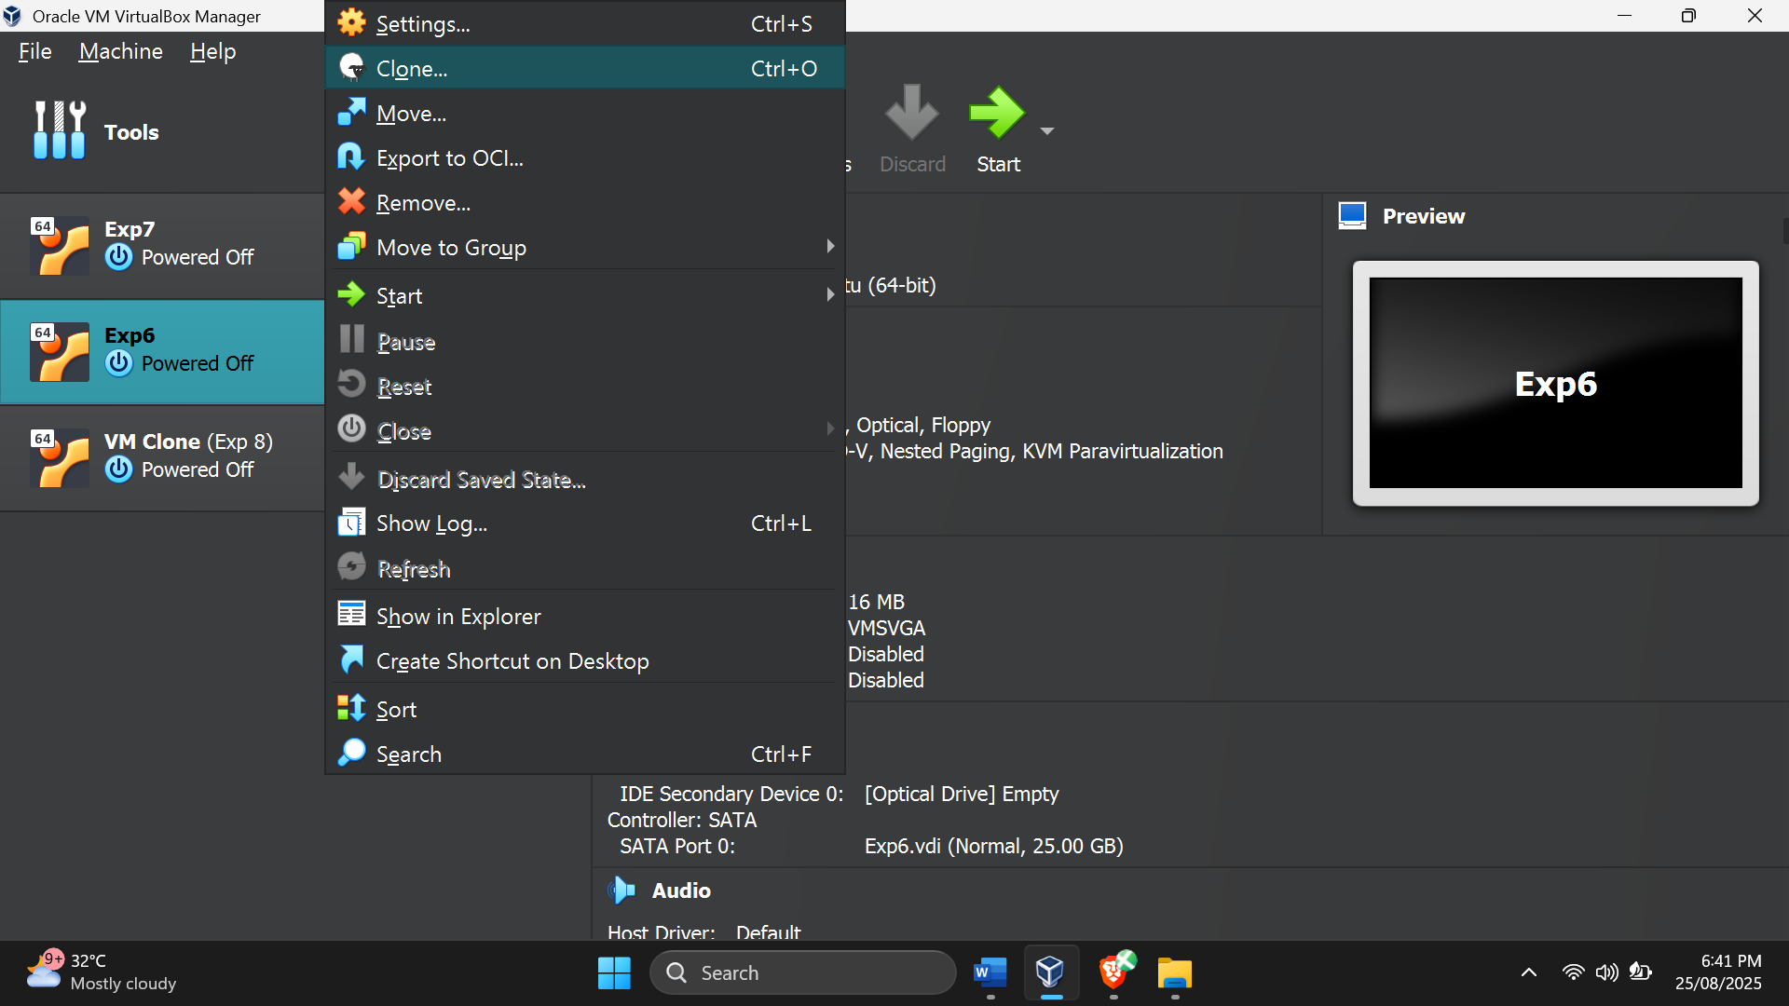

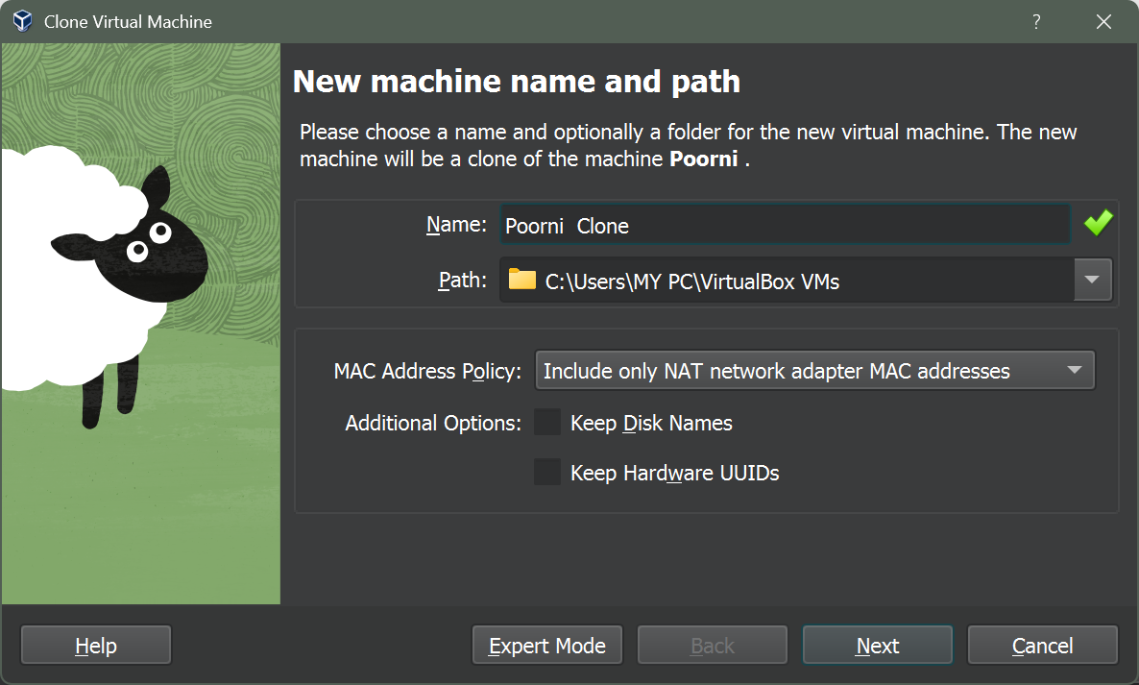

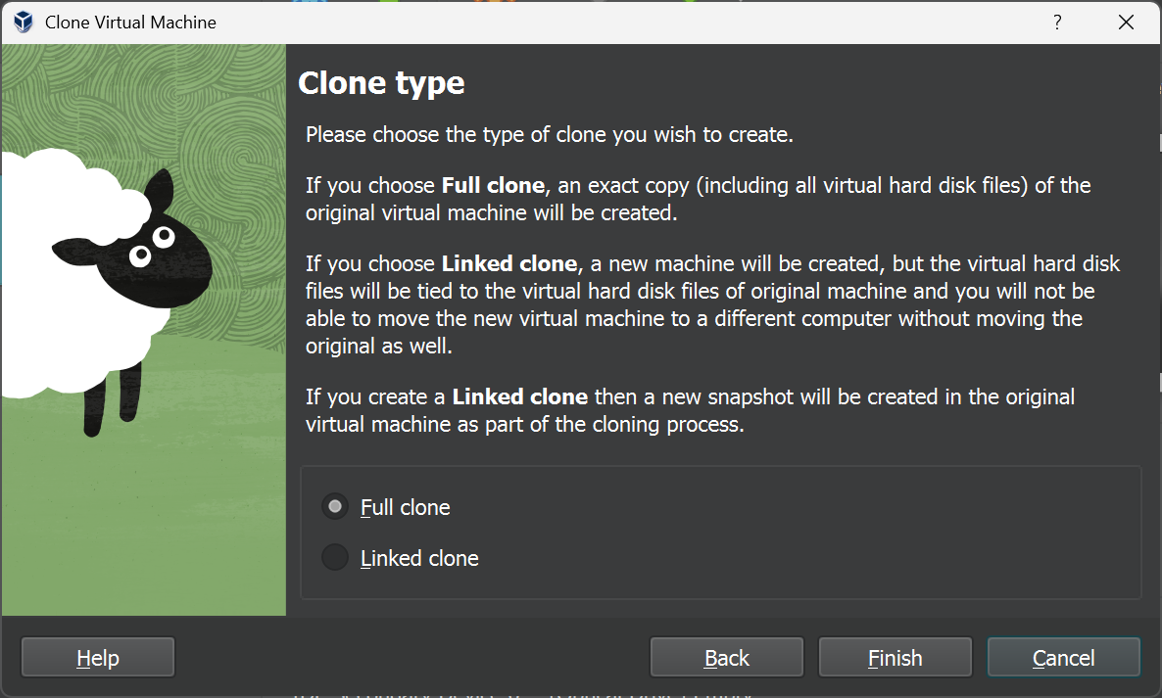

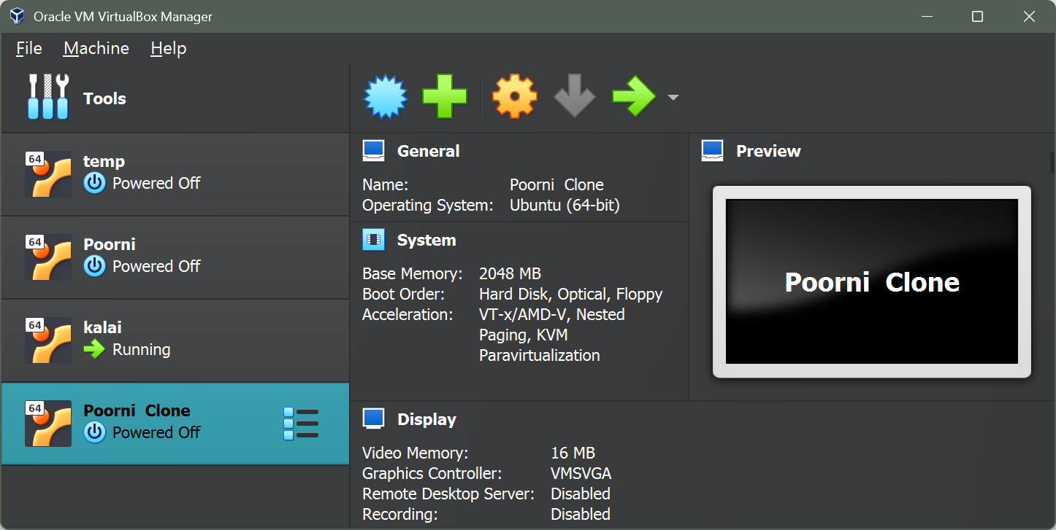

**Result:**

Thus the snapshot was created and run successfully